Abby Walker
Date of visit: September 14, 2017

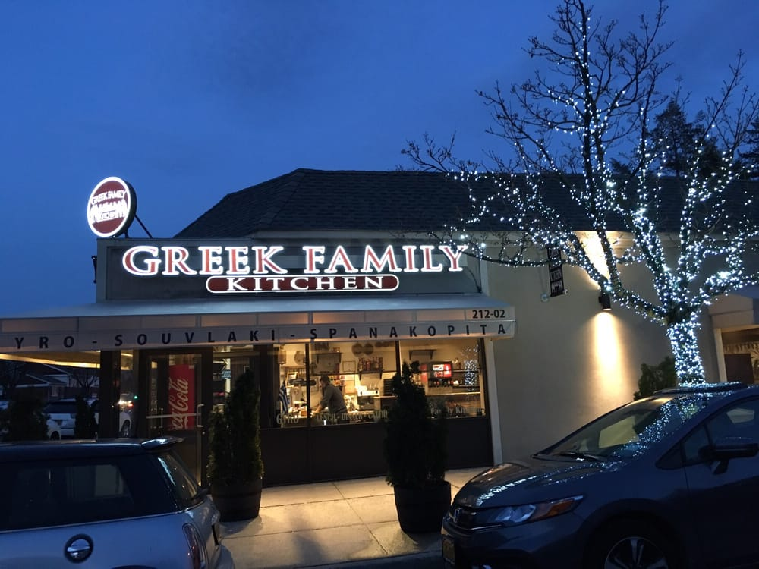 Restaurant: Greek Family Kitchen
Location: 212 – 02 Union Turnpike, Hollis Hills, NY 11364.
Phone: 718-470-1700
Email: GreekFamilyKitchen@gmail.com
Website: GreekFamilyKitchen.com

The restaurant is situated on the main street of Union Turnpike, in this area there are several speed radar so individuals need to be mindful of speeding, they do not have a parking lot however parking is available on the street. The Greek Family Kitchen provides traditional Greek dishes, the restaurant is family owned and operate the atmosphere is warm and friendly. Upon entering the restaurant the waitress greeted us with a smile and quickly provided a table for my co-workers and I. Shortly after we got seated our waitress brought water and the menus to us. The waitress was very knowledgeable about the menu items she was able to give us an idea of what some of the foods taste like and how they are prepare.
The restaurant is primarily eat-in however they also provide take out, online ordering, meal delivery and catering for any event small or large. Catered orders require a minimum of 24 hours to ensure delivery and orders must be prepaid. The restaurant is very family oriented the name speaks for itself it is relatively small but cozy it is decorated with family portraits from the 1960s. The restaurant has a great ambiance, the food was prepared with lots of love! Some of the plates were nicely garnished and the foods looked very fresh and attractive.

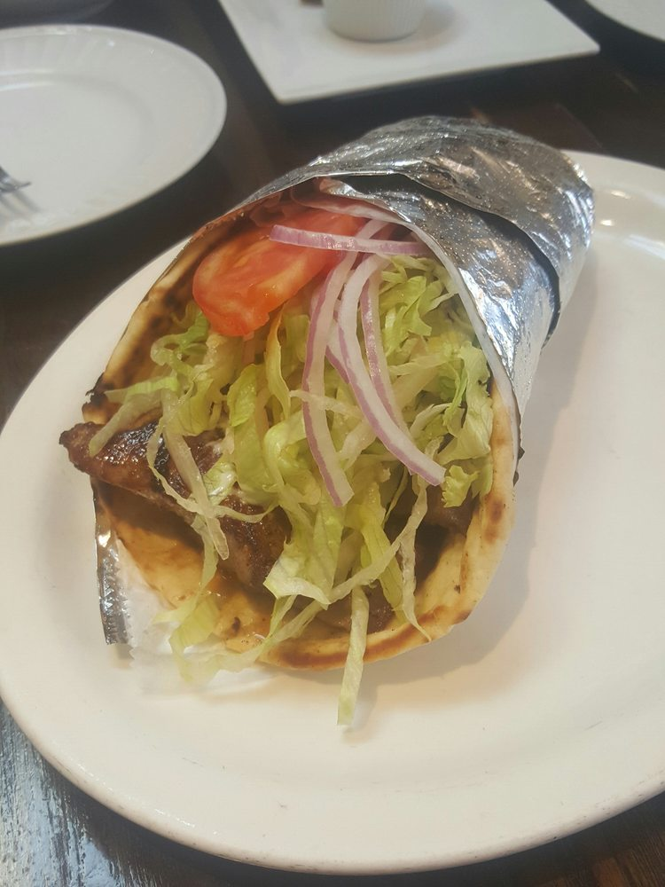

The cheapest meal on the menu is a burger which cost $ 6.50 and the most expensive meal on the menu is the Greek Family Platter which cost $ 39.95 it contains several types of animal proteins. My lunch started with a medium bowl of lentil soup which was absolutely delicious the portion size was perfect. I also had a chicken gyro wrap with lettuce, tomato, onion with tzatziki sauce it cost $16.95 it was prepared and served in a timely manner and it was very tasty and the price was pretty good.
The Greek Family Kitchen menu has a wide variety of meals that are suitable for most people. They have homemade Vegetarian Mousaka made of baked eggplant, potato, spinach, cheese and tomato sauce. There are whole wheat substitutes and grilled meats and vegetables that are suitable for diabetic diet, and low fat diets. There is also gluten free pita available upon request only for any sandwich, however there is an additional cost. They don’t have special diets on the menu however the meals can be modified to accommodate different needs. I was extremely satisfied with the food and the service, I will rate my meal and experience with three stars “really great”. ‘ Take out menu
