Sustainability Evaluation Report
5.12.2018
Queens County Farm practice Sustainable agriculture that is friendly to the environment and developed a connection to the surrounding communities. Queens’s county farm is aware of the connection that exist between environment, human and community health. The farm has a four- season growing program, they use passively heated cold frames and green house that provide fresh produce throughout the year for residents of New York City.
They start seeding in December before the hard frost as a result they start harvesting produce in March before other farms. They use animals for rotational grazing, the sheep’s eat the very top layer of grass and weed and the goats eat the lower layer they gets to the nitty gritty while the pigs restarts the land by rooting. The animals also participate in browsing which improve soil quality, animal health and restore a healthy ecosystem. The chickens are not rotated however the farmers open more grass space in a rotational way for them to graze and free range .The farm is strongly committed to keep their rich history, preserving the environment and providing healthy foods for the communities.
The farm has a composting program which is important to closing the fertility loop and improving the quality of the soil. Composting is a simple and great way to make huge changes in our environment, it reduces waste and provide nutrients to plants it’s also a good way to connect to nature. The farm has several compost sites that create healthy soil for many living creatures. The farm don’t depend on chemical fertilizer or insecticides they practice sustainable techniques such as crop rotation, timed planting, catch crops, companion planting and cover cropping to reduce weed and pest pressure. The cover crops are used to keep the soil moist, warm and nutrient dense, buckwheat is one of the main cover crop use at Queens County Farm. Peas, oats and clover are used in the fields.
Different plant feed the soil different nutrients, I learned that corn is a heavy feeder it pulls a lot of nutrients from the soil. A soil test is done once per year, soil samples are taken and send to the lab to be analyze the results will states the nutrients that are deficient or not having enough organic matter. The soil test is important to know how much compost is needed in certain area of the land. Currently I do not see an area of improving in regards to planting and composing however the prices for the plants could be a little cheaper.

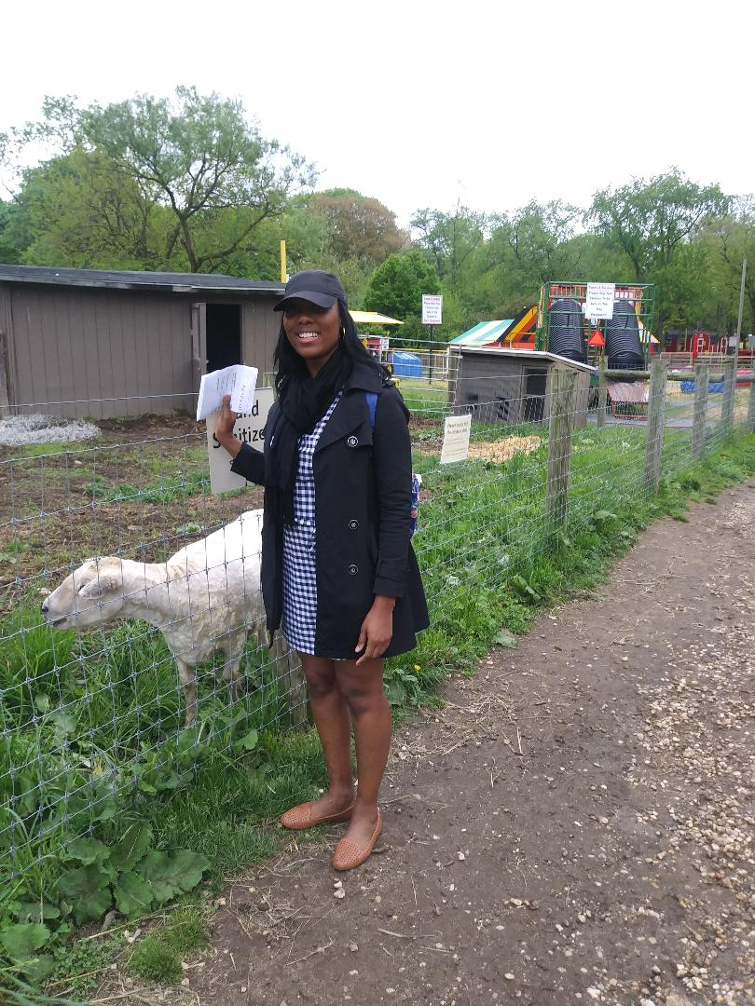
Sheep grazing
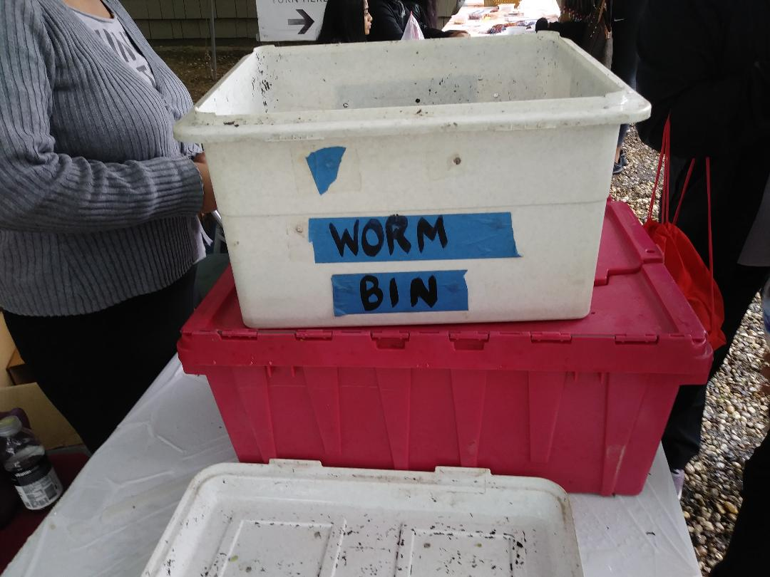
Worm bin composting

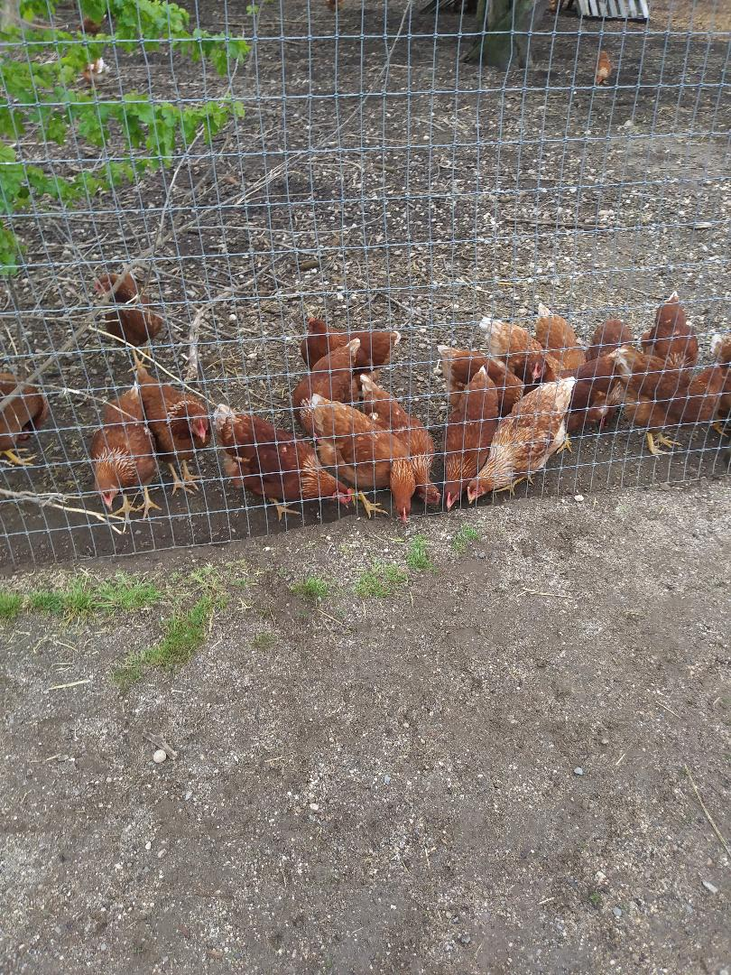
Chicken grazing / free ranging

